FRENCH AS A FOREIGN LANGUAGE
For international students
2023-2024 Academic year

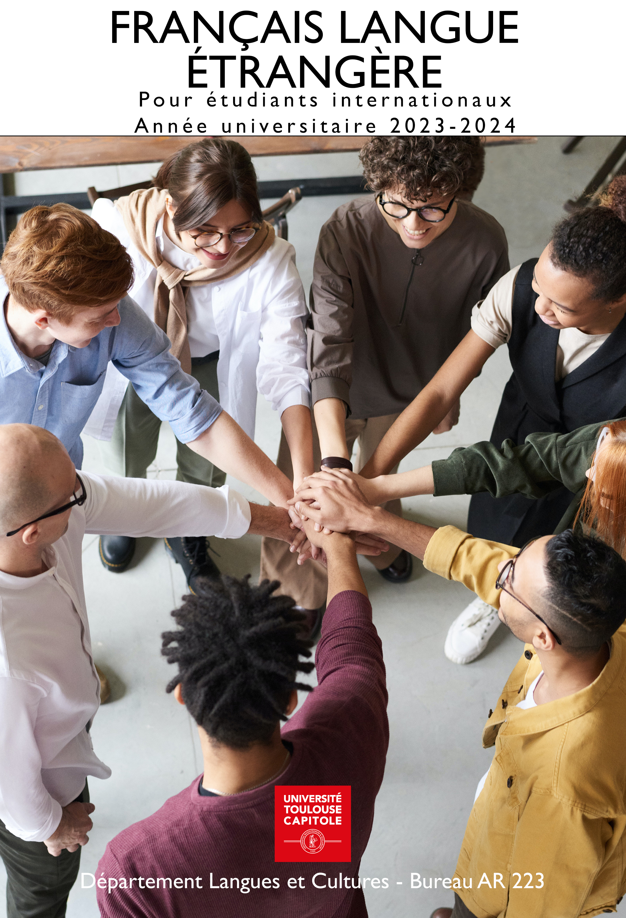

Three course proposals:

French Language and Culture Course (LCF)
Level groups from A0 to C1 (subject to a minimum number of participants)
24 hours per semester: 2 classes of 1.5 hours per week for 8 weeks
Mandatory attendance. 3 credits will be awarded under conditions*

Specialized French as a Foreign Language Workshops
3 workshops offered (subject to a minimum number of participants):
Legal French, Business French, Debating in French
13.5 hours per semester: 1 class of 1.5 hours per week for 9 weeks
Minimum B1 level required
Enrollment in one workshop per semester (only one enrollment per year for Legal French Workshop)
Mandatory attendance. 1 credit will be awarded under conditions*.

Conversation Workshops at the Language Resource Center / Centre de Ressources en Langues (CRL)
2 workshops of 1.5 hours offered each week for 10 weeks.
No attendance requirement, no credits awarded
Registration:

French Language and Culture Course (LCF) and Specialized French as a Foreign Language Workshops (FLES)
CONTACT: langues.etrangeres@ut-capitole.fr

Semester 1: registration until September 18, 2023
Semester 2: registration until January 15, 2024

How to Register:
- Provide proof of French level through one of the following certifications or tests:
- DELF/DALF, TCF, TEF
- or take the ELAO test: link toward road map
- Complete the online registration form
- Students will receive an email confirming their assignment to a group.
Please note: registration is only definitively confirmed if the student is present at the first class.

Semester 1 Class Dates:
- September 25 to November 24, 2023 for LCF courses
- September 25 to December 1, 2023 for FLES workshops
Semester 2 class Dates:
- January 22 to March 22, 2024 for LCF courses
- January 22 to March 29, 2024 for FLES workshops

Conversation Workshops at the Language Resource Center / Centre de ressources en langues
(CRL: levels A1 to C1)
CONTACT: crl@ut-capitole.fr
Weekly registration required at the CRL (Arsenal Library)
Certification: TCF, French Proficiency Test
For more information, visit the TCF website

French Language and Culture Course (LCF): Levels A0 to C1
Objectives | Acquisition of greater linguistic autonomy in everyday life and academic settings.  Gain in-depth knowledge of French society and culture.
Content | Pedagogical activities focused primarily on oral skills: comprehension of authentic audio and video materials and oral production activities such as role plays, presentations and debates.  Written comprehension and expression, reinforced with homework assignments
Assessment | Continuous assessment with mandatory attendance and regular work required.  * Successful completion of this course entitles students to 3 ECTS credits, subject to conditions.

Specialized French as a Foreign Language Workshops: levels B1 to C1
Assessment | Continuous assessment with mandatory attendance and regular work required.  * Successful completion of the workshop entitles students to 1 ECTS credit, subject to conditions.
 | Legal French Workshop
Objectives | Improve students’ command of the specific features of legal French by working on expanding their legal vocabulary.
Content | Analysis of legal texts and materials related to current events, exercises on legal vocabulary and syntax, presentations and discussions

Business French (Économics and Management)
Workshop
Objectives | Acquire basic vocabulary in economics and develop the ability to communicate in French in an academic and professional context.
Content | Useful vocabulary and structures for commenting on numerical data and graphs, presenting an organization, describing the workings of a company and its environment.

 | Debating in French
Objectives | Students will choose social issues that are important to them, and debate them together.
Content | Producing arguments in lively oral interactions, documentary research, group work.

CRL Conversation Workshops: levels A1 to C1
 | Exchanging on various topics
Objectives | Students will exchange freely on their cultures and experiences of living and studying in Toulouse.
Content | Discussions and role plays based on various materials (videos, film posters, news media and photos.)

DLC 1DDLC

